**Project Design Phase**

**Solution Architecture**

|  |  |
| --- | --- |
| Date | 15 june2025 |
| Team ID | LTVIP2025TMID32085 |
| Project Name | [**HealthAI-Intelligent-Healthcare-Assistant-Using-IBM-Granite-**](https://github.com/Rajkumar200526/HealthAI-Intelligent-Healthcare-Assistant-Using-IBM-Granite-) |
| Maximum Marks | 4 Marks |

**Solution Architecture Overview:**

**Solution architecture is a complex process that bridges the gap between business problems and technology solutions. Its goals include:**

* **Finding the best tech solution to solve existing business problems.**
* **Describing the structure, characteristics, behavior, and other aspects of the software to project stakeholders.**
* **Defining features, development phases, and solution requirements.**
* **Providing specifications according to which the solution is defined, managed, and delivered.**

**Example - Solution Architecture Diagram:**

**Figure 1: Architecture and data flow of the voice patient diary sample application**

**Solution Architecture Components:**

1. **Business Problem Statement:  
   [Briefly describe the business problem that the solution addresses.]**
2. **Proposed Technology Stack:  
   [List the technologies, frameworks, and tools that will be used in the solution.]**
3. **System Components:  
   [Outline the main components of the system, such as databases, servers, APIs, etc.]**
4. **Data Flow:  
   [Describe how data will flow through the system, including input, processing, and output.]**
5. **Integration Points:  
   [Identify any external systems or services that the solution will integrate with.]**
6. **Security Considerations:  
   [Discuss any security measures that will be implemented to protect data and ensure compliance.]**
7. **Scalability and Performance:  
   [Explain how the architecture will support scalability and performance requirements.]**

**v**

**Example - Solution Architecture Diagram:**

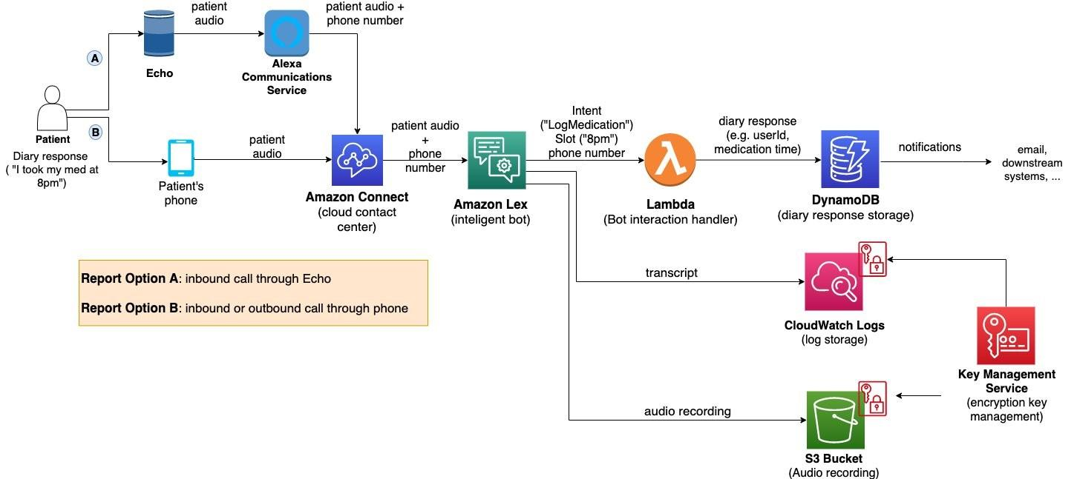

*Figure 1: Architecture and data flow of the voice patient diary sample application*

**Reference:** [**https://aws.amazon.com/blogs/industries/voice-applications-in-clinical-research-powered-by-ai-on-aws-part-1-architecture-and-design-considerations/**](https://aws.amazon.com/blogs/industries/voice-applications-in-clinical-research-powered-by-ai-on-aws-part-1-architecture-and-design-considerations/)